B Pharmacy First Year Subjects
Bachelor of Pharmacy or B. Pharmacy is one of the most studied courses of present time. Many students ever year enroll under B. Pharmacy colleges to study the course. It is a three year course, which is scheduled to be studied semester wise. It is an under graduation level course that is chosen to be studied by many students after their intermediate. Students who have studied intermediate with Bi.Pc background will go for under graduation into B. Pharmacy course. Qualified students from intermediate with Bi.Pc background will study B. Pharmacy in their under graduation level. The study of Pharmacy is all about art and science of preparing and dispensing new drugs and medicines for various illnesses and diseases.
Pharmacy is studied in various semesters. The number of semesters of Pharmacy varies from state to state. Students of Pharmacy along with gaining theoretical knowledge will also be able to gain practical knowledge as they get to perform various experiments. Pharmacy Council of India (PCI) is the one that is responsible to govern and manage the Pharmacy graduate level education in the entire country. It is a statutory body that is governed by the provisions of the Pharmacy Act, 1948 that was passed by the Indian Parliament.
Students who have completed their under graduation in Pharmacy can be able to live as a Pharmacist. They can manage their own medical shops; they can work in various labs to experiment new medicines for illnesses. Along with Pharmacy College’s offline, there are also named online Pharmacy colleges that offer good range of study to the students of the world. Many named universities around the globe offer online Pharmacy courses to the interested candidates. Those universities also provide Pharmacy degree to the qualified candidates. The online Pharmacy degree providing Schools include University of Florida, Kaplan University, Baker College, Lehigh University, University of Phoenix, Grand Canyon University and University of Liverpool.
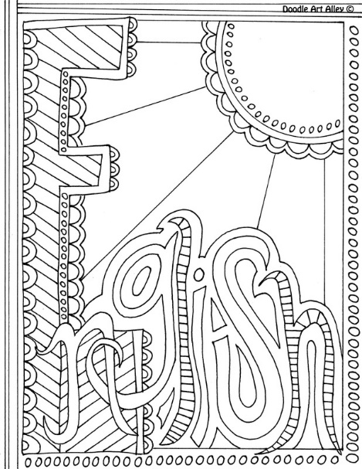

Subjects for First Year Pharmacy
The first year of B. Pharmacy consists of various subjects. Students who are willing to attain Bachelor Degree in Pharmacy needs to clear their intermediate with at least 50% of marks. They need to do their intermediate in Physics, Chemistry, Maths, or Physics, Chemistry, Biology or Physics, Chemistry, Maths and Biology subjects. The first year B. Pharmacy students need to study the subjects that were mentioned below. Students who have cleared all their subjects in B. Pharmacy first year will be promoted to second year. As it is a three year course and is a semester pattern, the subjects in the later two years will be divided into semesters.

- Remedial Mathamaticla Biology

- Advanced Mathematics
- Anatomy
- Physiology and Health Education
- Physical Chemistry
- Organic Chemistry
- Physical Pharmacy
- Basic Electronics and Computer Applications
- Pharmaceutical Analysis
- Inorganic Pharmaceutical Chemistry
- Pharmacognosy
Students who have entered into B. Pharmacy after their intermediate level education needs to study these subjects in their first year of Pharmacy. They need to clear all these subjects in order to get promoted to second year of Pharmacy. Few universities offer semester wise study, while few universities offer year full of study. Candidates who have plans to do Master Degree in research will do this B. Pharmacy course. Qualified candidates can either go for post graduation or can work in teaching profession.

Entrance Tests for Pharmacy
Just like we take EAMCET to enter Engineering, students who are willing to go for B. Pharmacy courses will take various entrance examinations. The entrance examinations include BHU B Pharma Entrance Exam, GPAT – Graduate Pharmacy Aptitude Test, MHT-CET Maharashtra Common Entrance Test etc. The entrance tests vary from state to state and institute to institute. Candidates depending on to which state they belong with take the entrance exam conducted by their respective states. Candidates can work in various areas of discipline like chemist shops, drug control administration, educational institutes, food and drug administration, health centers, hospitals, medical dispensing store, pharmaceutical firms, research agencies, sales and marketing departments etc.
As the intermediate exams have completed recently and most of the state results are released, now most of the students must be getting ready to apply for the entrance examinations to study B. Pharmacy. There will be definitely bright carrier who pursues B. Pharmacy. It is one of the leading courses at this point in time, which is being studied by zillions of people all around the globe. Students who are willing to do Pharmacy can apply to the Pharmacy entrance exams that will be soon notified.

