Tray Dryer is used for the best drying results in conventional process.

Tray Dryer- Pharmaceutical Equipment Introduction :
The most widely used and most general method of tablet preparation is the wet-granulation method. Its popularity is due to the greater probability that the granulation will meet all the physical requirements for the compression of good tablets. Its chief disadvantages are the number of separate steps involved, as well as the time and labor necessary to carry out the procedure, especially on a large scale. The steps in the wet method are weighing, mixing, wet massing, screening the damp mass, drying, dry screening, lubrication, and compression. The equipment involved depends on the quantity or size of the batch and
the percent active ingredient per total weight of the tablets. Wet massing can be performed by:
1. Low Shear mixers/granulators,
2. High Shear mixers/granulators,
3. Fluid-Bed granulators/Tray dryers,
4. Spray Dryers, or
5. Extruders and Spheronizers.
Dryers are used to remove liquids or moisture from bulk solids, powders, parts, continuous sheets or other liquids by evaporation or sublimation. Dryers can be broken up into two main types: direct and indirect. Direct dryers convectively heat a product through direct contact with heated air, gas or a combusted gas product. Indirect dryers conductively heat a product through contact with a heated wall.
Tray Dryer is used for the best drying results in conventional process. It is a double walled cabinet with Single or Two doors. The gap between two walls is filled with high density fibre glass wool insulation material to avoid heat transfer. Doors are provided with gaskets. Stainless steel trays are placed on the movable trolleys. Tray Dryer is provided with control panel board, process timer, Digital temperature controller cum indicator etc. Tray Dryer is available in capacities ranging from 6, 12, 24, 48, 96, 192 trays.
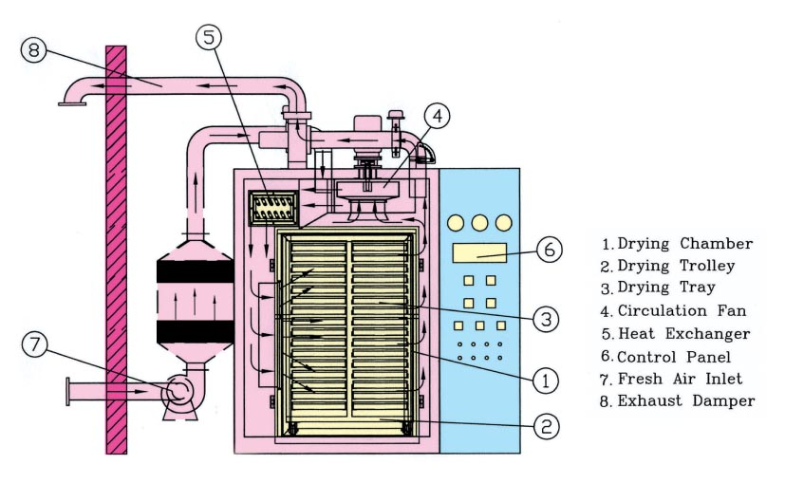

Tray Dryers Theory
A tray Dryer is an enclosed insulated chamber in which trays are placed on top of each other in trolleys. Tray Dryer are used where heating and drying are essential parts of manufacturing process in industries such as Chemicals, Dye stuff, Pharmaceutical, Food Products, Colours etc. The material to be dried either wet or solids are placed in the trays. Heat transfer is by circulation of hot air by electric heaters or steam in radiator coils. Blower fans are installed inside to ensure proper circulation and transfer of heat. A control panel to control the temperature and other parameteres is fixed outside the dryer. These dryers are available in Mild Steel, Stainless Steel or construction. Tray dryer is used for drying of pigments, food, bakery, electrodes, chemical and plastic powders.
The Drying ovens are normally available with choice of heating mode, as electrically heated / steam heated & thermic fluid heated..
In electrically heated model, digital temperature controller provided with digital timer to facilitate working day and night. In steam & thermic fluid heated model, digital temperature indicator is provided with digital timer , but the temperature controller is not supplied with the machine.
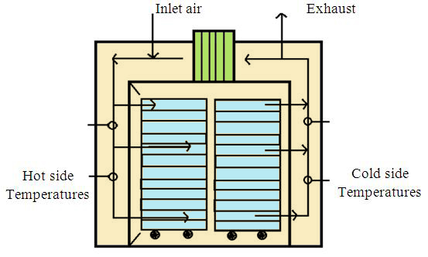
A highly effective recirculating air system is provided. The heated air, is recirculated with fresh air in selected proportions for optimum drying. The system is designed so that the materials at the top & the bottom dry simultaneously.
Uniform air circulation, controlled temperature, sturdy construction and large working space are the valuables of the oven which is suitably designed to cover wide temperature range, loading and unloading is faster and simple. In higher capacities trays trolley rolls in and out of the chamber. For continuous operation a spare trolley can be had for loading while the drying cycle is taking place. Digital temperature controller with digital timer are supplied to facilitate working day and night.

Tray Dryer Working Principle
In tray dryer hot air is continuously circulated. Forced convection heating takes place to remove moister from the solids placed in trays.
Simuilaneously the moist air is removed partially.
Wet solid is loaded in to the trays. Trays are placed in the chamber.
Fresh air is introduced through in let, which passes through the heaters and gets heated up.
The hot air is circulated by means of fans at 2 to 5 metre per second.
Turbulent flow lowers the partial vapour pressure in the atmosphere and also reduces the thickness of the air boundary layer.
The water is picked up by the air. As the water evaporates from the surface, the water diffuses from the interior of the solids by the capillary action.
These events occur in a single pass of air. The time of contact is short and amount of water picked up in a single pass is small.
Therfore the discharged air to the tune of 80 to 90 % is circulated back through the fans. Only 10 to 20% of fresh air is introduced.
Moist air is discharged through outlet. Thus constant temperature and uniform air flow over the materials can be maintained for achieving uniform drying.
In case of the wet granules as in tablets and capsules drying is containued until the desired moister content is obtained.
At the end of the drying trays or trucks are pulled out of the chamber and taken to a tray dumping station.

Tray Dryer Diagram:
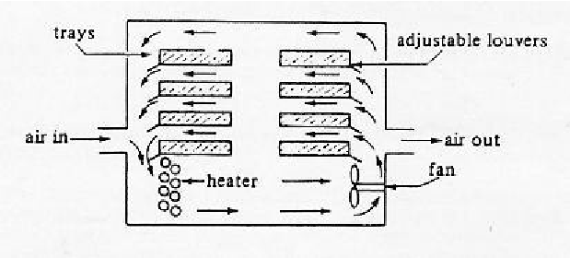

Tray Dryer Manufacture Construction & Specifications:

The Tray dryer should be of robust construction built on formed angles of 3mm+ thick sheet and suitably reinforced with angles and sections.
The dryers external walls should be manufactured from 1.6mm thick Stainless Steel sheets of 304 quality or more.
The internal of the dryer is built of 1.6 mm thick quality sheets. The internal structure should be fully TIG welded and all the internals have ground smooth surfaces.
It should be insulated with minimum 50 mm thick glasswool insulation and Cladded with S,S, Polished sheets.
The dryer should be having a fresh air inlet through 20 Micron PP cloth filters and a adjustable air outlet flap and a door at the front. The door is explosion proof and is locked with the help of spring loaded ball latches with suitable pressure. Door lips are having Neoprene rubber Gasket to prevent leakages.
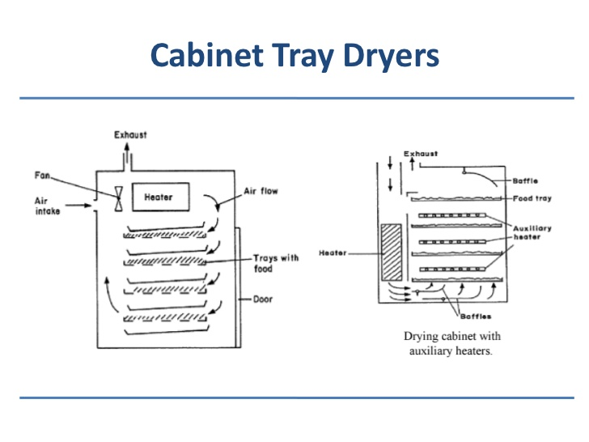
The design and manufacture of the dryer is of high standard of GMP and has an aesthetic look. It is buffed externally to 150 grit matt finish and internally buffed to 220 grit mirror finish.

Electrical heating
The Air inside the Tray Dryer is heated by "U" tube S.S.304 air heaters each of 1 KW.The heaters are fitted on the sides of the dryer to facilitate uniform heating. Maximum temperature attained inside the dryer is 100' C and will be indicated and controlled by a Digital Temperature indicator cum controller over full range of heating load.

Total heating load for it will be
12 Trays Dryer - 4 KW
24 Trays Dryer - 6 KW
48 Trays Dryer - 12 KW
96 Trays Dryer - 24 KW

The heaters will be inserted inside tubular pipe to prevent it from becoing RED HOT. The terminals of the heaters will be brought outside the dryer to make it more safe for operations for solvent based products.

Racks And Trolleys
Racks are provided for trays insdie the Dryer. They are of fixed type for 12 and 24 Tarys Models. For 48 and 96 Trays Models. Racks are provided with wheels to slide them in and out of the Dryer. An additional S.S, trolley for Racks for outside movement can be provided on request

Drying tests comparing the fluidized bed and a tray dryer for a number of tablet granulations indicated that the former was 15 times faster than the conventional method of tray drying. In

